Registration form 5 (All fee’s in EURO)

Hotel booking – ANDERS HOTEL
Contact information
Country
Contact person
E-mail
Telephone

Hotel rooms
Category | Fee p. room | Number | Arrival (date) | Departure (date)
Single room - standard | 110
Double room for single use | 135
Double room - standard | 145
Wooden houses with two bedrooms
Category | Fee p. person | Number | Arrival (date) |  | Departure (date)
FOR 2 PERSONS | 65
FOR 3-4 PERSONS | 45
THE ROOM PRICE APPLIES ONLY TO THE DURATION OF THE TOURNAMENT

Paying information
Mark alternative with X
 | Send us an invoice |  | We pay to the bank account below
Send us the invoice to the following address:

Other remarks
In case of resignation 30 days before the start of the tournament, 100% money back.

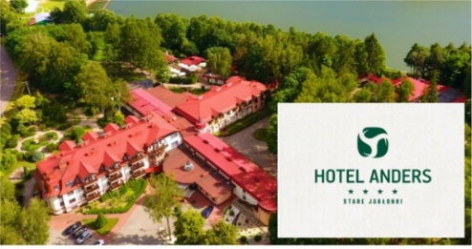 | Hotel Anders  ul. Spacerowa 2, 14-133 Stare Jabłonki  TEL.: + 48 89 642 70 00  EMAIL: accomodation@hotelanders.pl
Please email this form to accomodation@hotelanders.pl (copy to: bbil1@o2.pl)
before February 15th, 2024.
Full payment before April 30th, 2024, to:
mBank S.A. Oddział Korporacyjny w Olsztynie SWIFT CODE: BREX PL PW
EUR – IBAN: PL54 1140 1111 0000 4166 9100 1019
USD – IBAN: PL58 1140 1111 0000 4166 9100 1044

