CENTER HOTELS,

booking.
ESGA GOLF 2024

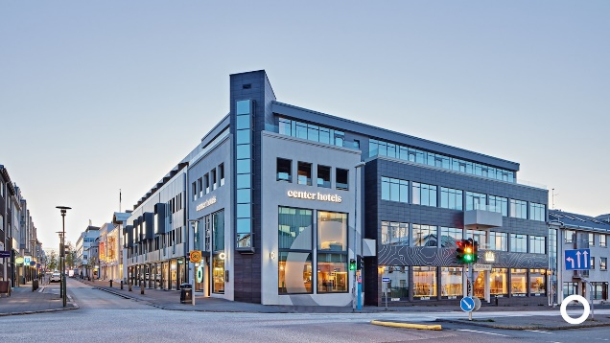
CENTER HOTELS PLAZA
Room with Breakfast, free Wi-Fi and taxes
Single room - one bed
Double room – Twin room

CENTER HOTELS ARNARHVOLL
Room with Breakfast, free Wi-Fi and taxes
Single room - one bed
Double room – Twin room

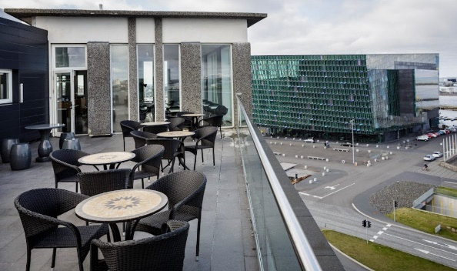
CENTER HOTELS LAUGARVEGUR
Room with Breakfast, free Wi-Fi and taxes
Single room - one bed
Double room – Twin room

CENTER HOTELS MIDGARDUR
CENTER HOTELS give you a code for our online booking engine. The code is valid for bookings in all Centre Hotels with stay dates between 29 July 2024 to 03 August 2024.
Description: ESGA55-Team Seniors Championship & Cup
15% discount from online BAR rates, valid in august 2024.
HERE you have a booking link which guests can use to access this promo code.
Room with Breakfast, free Wi-Fi and taxes
Single room - one bed
Double room – Twin room

Please book before Nov. 15th, 2023.
Please send copy to LEK@golf.is

CENTER HOTEL PLAZA
https://www.centerhotels.com/en/hotel-plaza-reykjavik
Address Aðalstræti 4, 101 Reykjavík Tel. +354 595 8550
Email reservations@centerhotels.com
CENTER HOTELS ARNARHVOLL
https://www.centerhotels.com/en/hotel-arnarhvoll-reykjavik
Address Ingólfsstræti 1, 101 Reykjavík Tel. +354 595 8540
Email reservations@centerhotels.com
CENTER HOTELS LAUGARVEGUR
https://www.centerhotels.com/en/hotel-laugavegur-reykjavik
Address Laugavegi 95-99, 101 Reykjavík Tel. +354 595 8570
Email reservations@centerhotels.com
CENTER HOTELS MIDGARDUR
https://www.centerhotels.com/en/hotel-midgardur-reykjavik
Address Laugavegi 120, 101 Reykjavík Tel. +354 595 8560
Email reservations@centerhotels.com
